

Dr. Jennifer, Lopez inc.
2015-04-08
Dr. Lopez
PSC 0717, Box 8261, APO AE 15928
Phone: 6196424210
Fax: 9836460431

Re: Kelly, Yoder
PHN: 9431900758
Birthdate: 16-Sep-1986
Address: 15674 Jeremiah Estate, Ericborough, DC 40997
Patient number: 4603515610

To Whom It May Concern:

This is a medical letter to state the above patient is pregnant with expected delivery date of 04-Feb-2025. Hoping this information is satisfactory for your requirements.

Thank you.

Sincerely,
Dr. Jennifer, Lopez
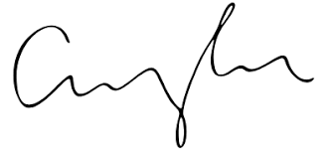
FRCS© NCMP
Clinical Assistant Professor, UBC
Department of Obstetrics and Gynecology SMH

